XSIS Assessment Backend Developer Test Unit Testing

Language = PHP 8.2.4

Framework = Laravel 10.13.5

Database = MySQL / 10.4.28-MariaDB

Test Case

1. Add New Movie
2. Get List of Movie
3. Get List of Specific Movie given the ID
4. Update Specific Movie given the ID
5. Delete the Movie

Add New Movie

1. Create JSON that will be send as post parameter to API api_url/api/Movies with POST method

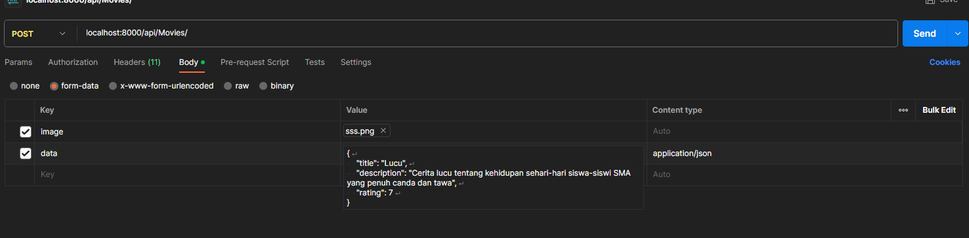

{

"title": "Lucu",

"description": "Cerita lucu tentang kehidupan sehari-hari siswa-siswi SMA yang penuh canda dan tawa",

"rating": 7

}

1. Send it to the API
2. If its successfully added, a return message will appear



Get List of Movie

1. Retrieve list of movie from api-url/api/Movies/ with GET method



1. List of movies with active status will be displayed

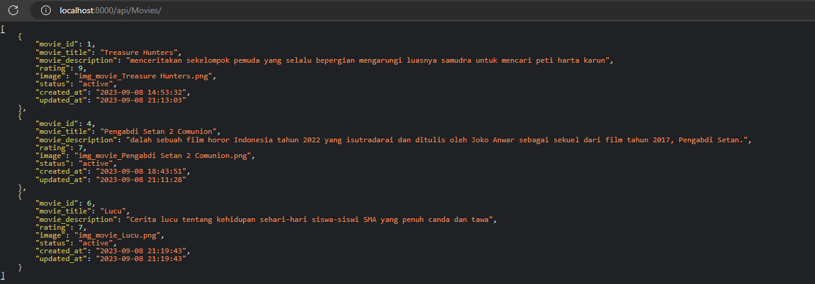

Get Specific Movie Data Given the ID

1. Retrieve movie data from api-url/api/Movies/{Movie ID} with GET method



1. Movie Data of given ID will be displayed

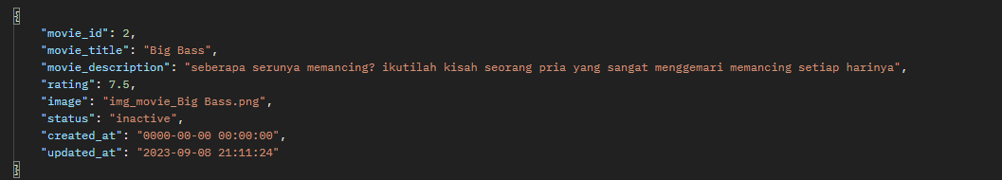

Update Movie Data given the ID (test case using POST method instead of patch because of using Postman)

1. Build JSON Structure then send it to api_url/api/Movies/{Movie ID} with PATCH method

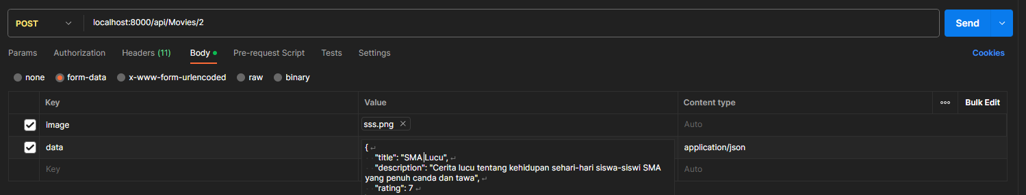

{

"title": "SMA Lucu",

"description": "Cerita lucu tentang kehidupan sehari-hari siswa-siswi SMA yang penuh canda dan tawa",

"rating": 7

}

1. Message will appear after the task finished



Delete a Movie given the ID (in this case, the movie’s status is set to inactive)

(follow up from the retrieve all movies case)

1. Send a data to api_url/api/Movies/{Movie ID} with DELETE method



1. Message will appear



1. Retrieve list of movies again and the “deleted” movie will not shown

